**ShawMhor Early Years Public Holidays and In-Service Days 2025/26**

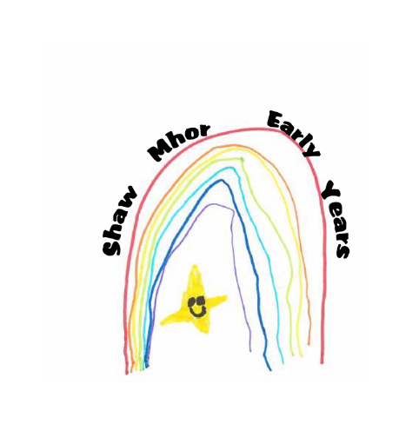

|  |  |  |
| --- | --- | --- |
| **School Term Contract**  **(39 Weeks)** | **Nursery Closed**  **(All Contracts)** | **In-Service Days** |
| **Mid Term Break**  Monday 17 February 2025  Tuesday 18 February 2025 | **Easter Weekend**  Good Friday 18 April 2025  Easter Monday 21 April 2025 | Wednesday 19 February 2025  Thursday 22 May 2025 |
| **April – Spring Holiday**  Monday 7 April to Monday 21 April 2025 (inclusive)  ***Nursery closes 2.30pm Friday 7 April 2025***  ***Children Return Tuesday 22 April 2025*** | **May Public Holidays**  Monday 5 May 2025  Friday 23 May 2025  Monday 26 May 2025 | Tuesday 12 August 2025  Wednesday 13 August 2025  Friday 10 October 2025 |
| **Nursery closes (term time)**  Wednesday 25 June 2025 1pm | **Glasgow Fair Holiday**  Monday 21 July 2025 |  |
| **Return date for children**  Thursday 14 August 2025 | **September Weekend**  Friday 26 September 2025  Monday 29 September 2025 |  |
| **October Mid-Term**  Monday 13 to Friday 17 October 2025 (Inclusive) | **Christmas/New Year**  Thursday 25 December to Friday 2 January 2026 (inclusive)  ***Nursery Closes Wednesday 24 December 2025***  ***Children Return Monday 5 January 2026*** |  |
| **Christmas/New Year**  Monday 22 December 2025 to Friday 2 January 2026 (inclusive)  ***Nursery closes Friday 19 December 2025 2.30pm***  ***Children Return Monday 5January*** |  |  |